**PRACTICAL 10**

**AIM:** Create dashboard and storytelling using tableau.

**THEORY**

In Tableau, a **story** is a sequence of visualizations that work together to convey information. You can create stories to tell a data narrative, provide context, demonstrate how decisions relate to outcomes, or to simply make a compelling case. A story is a sheet, so the methods you use to create, name, and manage worksheets and dashboards also apply to stories. At the same time, a story is also a collection of sheets, arranged in a sequence. Each individual sheet in a story is called a **story point**. When you share a story —for example, by publishing a workbook to Tableau Public, Tableau Server, or Tableau Cloud—users can interact with the story to reveal new findings or ask new questions of the data.

Dataset: The sample superstore dataset provided by tableau.

# STEPS

1. Click the new story tab. Tableau opens a new story as your starting point.
2. By default, your story gets its title from the sheet name. To edit it, right-click the sheet tab, and choose rename sheet.
3. To start building your story, double-click a sheet on the left to add it to a story point. In Tableau Desktop, you can also drag sheets into your story point. When you add a sheet to a story point, that sheet remains connected to the original sheet. If you modify the original sheet, your changes will automatically be reflected on the story points that use it.
4. Click Add a caption to summarize the story point.
5. To further highlight the main idea of this story point, you can change a filter or sort on a field in the view. Then save your changes by clicking **Update** on the story toolbar above the navigator box.
6. Add another story point by doing one of the following:
7. Click **Blank** to use a fresh sheet for the next story point.
8. Start customizing a story point and click **Save as New** on the toolbar above the navigator box.
9. Click **Duplicate** to use the current story point as the basis for a new one.
10. You can refine the look of your story using the options on the **Layout** tab.
11. Click the **Layout** tab.
12. Choose a navigator style that best suits your story, and show or hide the next and previous arrows.
13. Click the **Size** drop-down menu and select the story you want the dashboard to fit inside.

**RESULTS**

1. **Sheet 01**

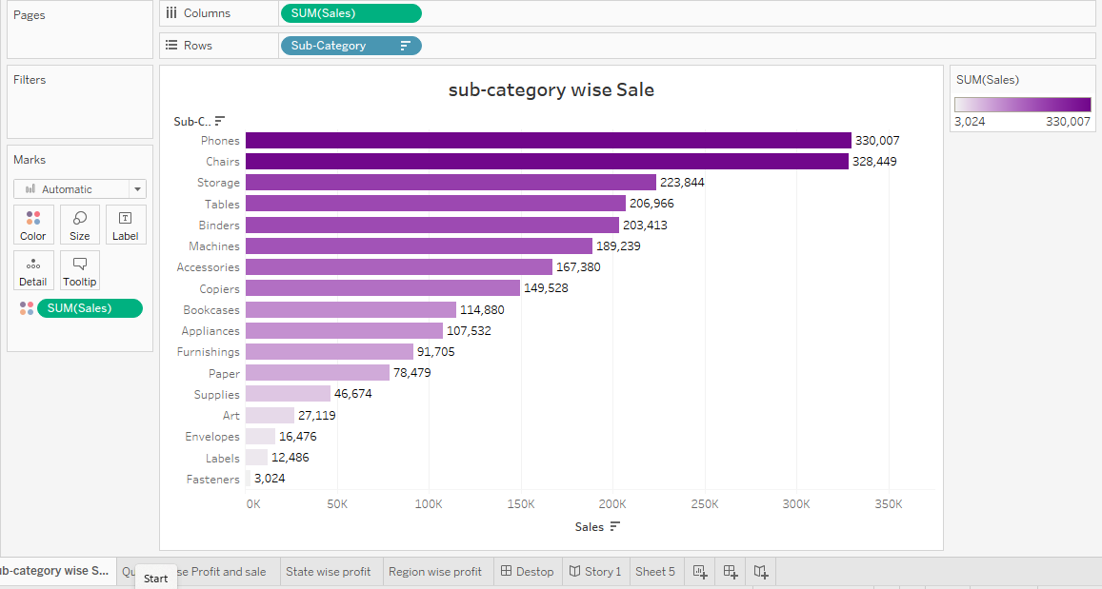

1. **Sheet 02**

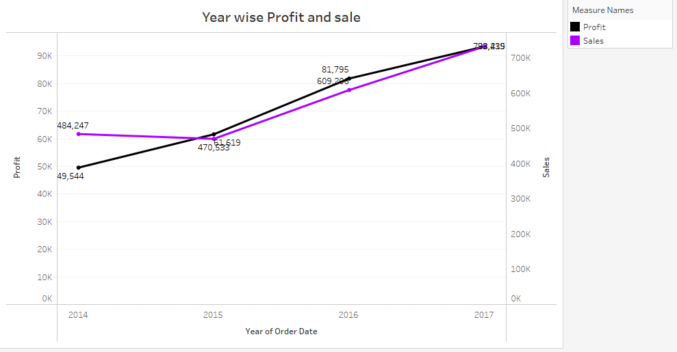

1. **Sheet 03**

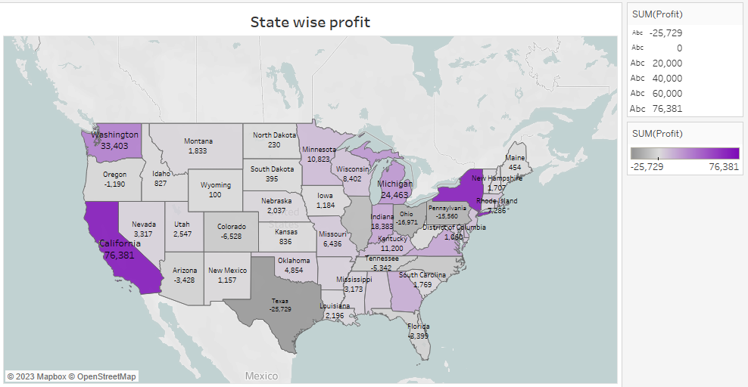

1. **Sheet 04**

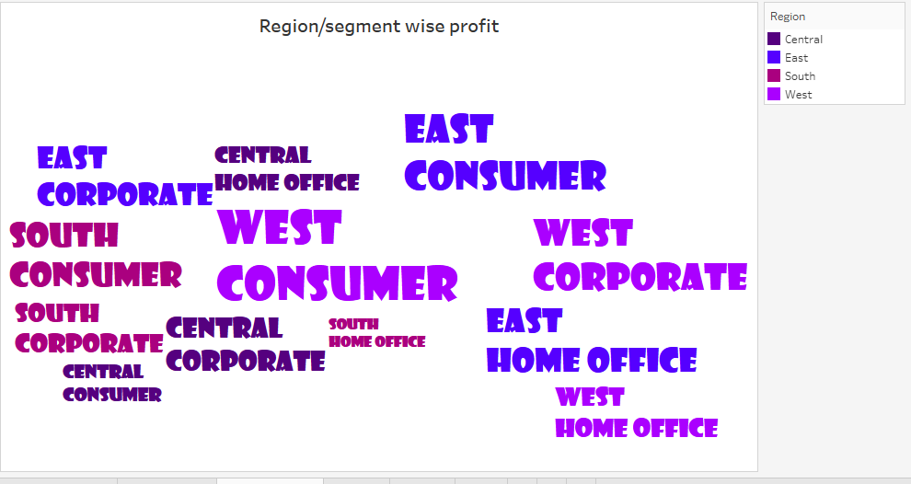

1. **Sheet 05**

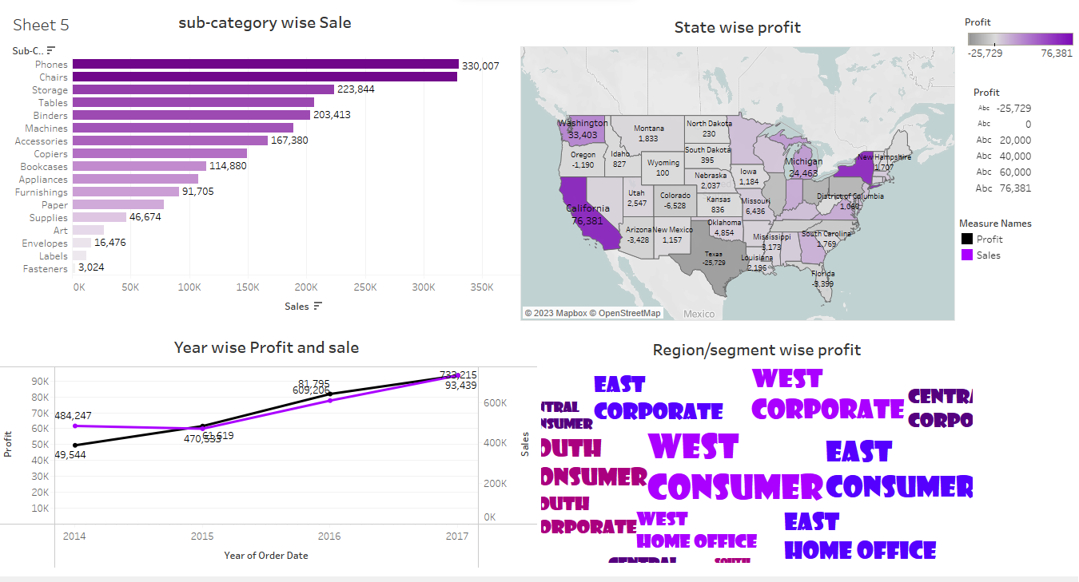

1. **Sheet 06**

